# ReactJS-HOL

Question: Create a new React Application with the name “myfirstreact”, Run the application to print “welcome to the first session of React” as heading of that page.

Code:

App.js

import React from 'react';

function App() {

return (

<div>

<h1>Welcome to the first session of React</h1>

</div>

);

}

export default App;

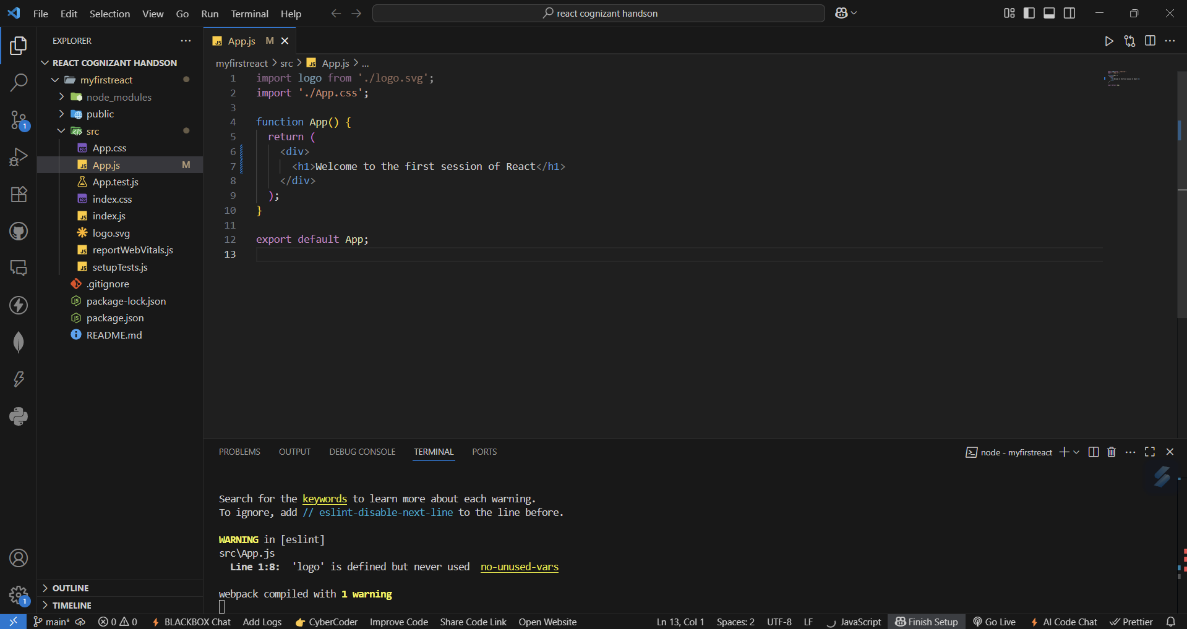File Structure:

Output:

Q1: Define SPA and its benefits.

Ans: **SPA (Single Page Application):** A web app that loads a single HTML page and dynamically updates content without reloading the page.  
**Benefits:** Faster navigation, smoother UX, less server load.

Q2: Define React and identify its working.

Ans: A JavaScript library for building user interfaces. It uses **components** and a **virtual DOM** for efficient updates.

Q3: Identify the differences between SPA and MPA.

Ans:

| **Feature** | **SPA** | **MPA** |
| --- | --- | --- |
| Page reload | No | Yes |
| Speed | Faster | Slower |
| Dev complexity | Higher (client-side routing) | Lower |

Q4: Explain Pros & Cons of Single-Page Application.

Ans: **Pros:**

* Fast navigation.
* Improved user experience.
* Less server interaction.  
  **Cons:**
* Initial loading time may be longer.
* SEO can be challenging.
* Requires JavaScript to be enabled.

Q5: Define virtual DOM.

Ans: A lightweight copy of the real DOM used by React to optimize updates and rendering.

Q6: Explain Features of React.

Ans:

• Component-based architecture

• Unidirectional data flow

• JSX (JavaScript + HTML)

• Virtual DOM

• High performance and reusability